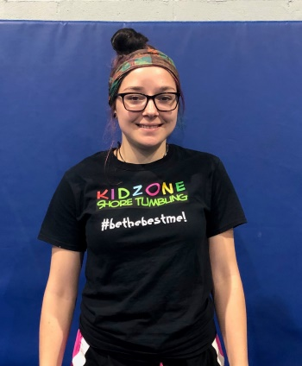

Hi! My name is Devin Scully and I help coach Tumbling classes as well as Ninja kids. I have done competition cheer for 5 years and high school gymnastics for 3. I started my journey of learning to love this sport at Cheer Gym. My favorite part about gymnastics and cheer was always tumbling.

I have lived with my grandmother my whole life and she always taught me to have love and compassion towards others and now it just comes naturally to me. I absolutely love working with kids and it's always such a good feeling to see them learning new skills and having a good time. I aspire to be the best role model I can be for all the kids around me.

